# Test 2

# Note: Record your answers on the last page

Date: Name:

Grade: /28 Student #

1. Define the term Radius.
2. What is the square root of the number 256?
3. The area of a square building is 961 sqft. What is the length of one side?
4. The height of a rafter on a roof is 9’8”. The width of the roof is 25’4”. What is the length of the rafter on the building?
5. Express 400 km in 5 hours as a ratio in its simplest form.
6. Two workers divide $360.00 between them in a ratio of 8:7. How much does each person get?
7. A 4” pulley revolving at 1750 rpm drives an 8” pulley and what rpm?
8. What is the diameter of a pulley that revolves at 420 rpm if it is driven by a 4” pulley running at 1500 rpm?
9. Calculate the rim speed of a 6” shaper cutter revolving at 8000 rpm.
10. A saw blade has a diameter of 13” and a motor speed of 3600 rpm. What size of pulleys should be used to obtain an approximate optimum rim speed of 14,000 lfm? (‘aint no 1” pulleys).
11. A 24” dia. Bandsaw has a center-to-center measurement of 38”. What is the blade length to the nearest ¼”?
12. Using the following information, calculate the total glue ratio requirements

**Quantity:** 75, Five-ply panels **Coverage:** 20 grams/ sqft

**Finished size:** 34” x 21” **Waste:** 10%

**20: 4: 1 ratio** of resin, catalyst and water respectively

**Answers: (all questions worth 2 marks unless otherwise noted.)**

1.

2.

3.

4.

5.

6.

7.

8.

9.

10. /3

11.

12. Total Square footage to cover: (5 marks total)

Total Grams of Glue (with waste):

20 parts resin:

4 parts catalyst:

1 part water:

# Formulas

Area of a square = l2

C2= a2 + b2

Pulley ratio = (Driving pulley \ driven pulley) x RPM of motor

Rim Speed (LFM) = $\frac{πxd}{12}$ x rpm

Bandsaw = (π x d) + (2 x center to center distance)

Rafter Question:

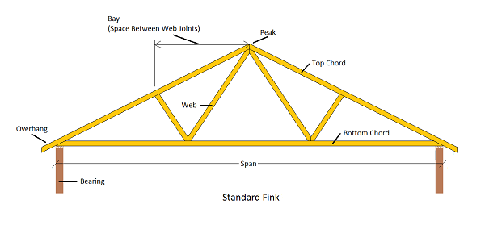

Span = roof Width

Rafter Height